34.201.34.209 àworkstation
54.198.81.223 àchef server
Chef-server àsk0014260.hopto.org

Chef Server installation youtube
https://www.youtube.com/watch?v=oeH7VB93FrU

Chef Server URL
https://api.chef.io/organizations/sanjeevbookdepot/getting_started
username: sk0014260
Password: Techmahindra1
Host Name
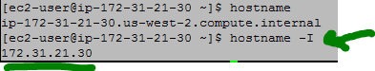

CPU Info
cat /proc/cpuinfo

Ohai use
ohai memory/total

How to create user on AWS RedHat
Sudo useradd -md /home/sanjeev -s /bin/bash Sanjeev

Adding user Sanjeev to group ec2-user
[ec2-user@ip-172-31-21-30 myrepo]$ sudo gpasswd -a sanjeev ec2-user
Grant Sudo previllege to Sanjeev
sudo visudo
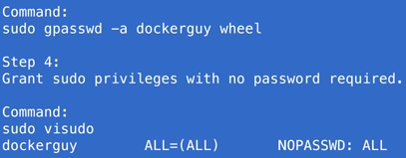

Creating Public private key
sudo su - sanjeev
ssh-keygen
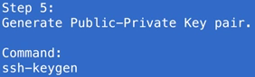
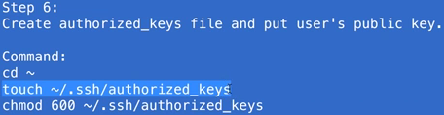
=============
Install chek-dk from below url on Radhat
wget https://packages.chef.io/files/stable/chefdk/1.3.43/el/7/chefdk-1.3.43-1.el7.x86_64.rpm
sudo rpm -ivh chefdk-1.3.43-1.el7.x86_64.rpm

to work with bash to chef execute below
echo 'eval "$(chef shell-init bash)"' >> ~/.bash_profile

To verify chef installed successfully
chef verify

Creating Repo
chef generate repo myrepo

Creating cookbook
cd ~/myrepo/cookbooks
chef generate cookbook myfirstcookbook

Writing recipe in cookbook à myfirstrecipe.rb
cd ~/myrepo
vim cookbooks/myfirstcookbook/recipes/myfirstrecipe.rb

package 'git' do
action :install
end

package 'tree' do
action :install
end

package 'vim' do
action :install
end

Execute myfirstrecipe.rb
cd ~/myrepo
sudo chef-apply ./cookbooks/myfirstcookbook/recipes/myfirstrecipe.rb
chef-apply is used to run a single recipe
chef-client is used to run cookbook

how to include myfirstrecipe.rb to default.rb
vim ~/myrepo/cookbooks/myfirstcookbook/recipes/default.rb
#add below line
include_recipe ‘myfirstcookbook::myfirstrecipe’

sudo chef-client --local-mode -r "recipe[myfirstcookbook]"
or
sudo chef-client -z -r “recipe[myfirstcookbook]”
Calling recipes from 2 cookbook below apache and workstations

How to get host value by using ohai
# How to print variable value #{node[‘hostname’]}
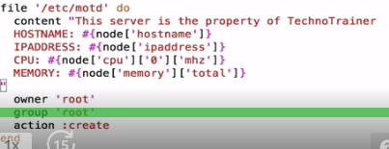
end

file '/var/www/html/index.html' do
content "<h1> Hello Chef </h1>
<h2>Hostname: #{node['hostname']} </h2>
<h2>ipaddress: #{node['ipaddress']} </h2>"

end

Ohio à
Ohai is a tool that is used to detect attributes on a node, and then provide these attributes to the chef-client at the start of every chef-client run.

Template Generation
chef generate template cookbooks/myfirstcookbook mdot

File Generation
chef generate file cookbooks/myfirstcookbook index.html

Creating user/group with Chef
user 'sanjeev' do
comment "root user sanjeev"
uid '1234'
#gid '1234'
shell '/bin/bash'
password 'sanjeev'
end

group 'awsadmin' do
members 'sanjeev'
append true
end

Notifications¶
A notification is a property on a resource that listens to other resources in the resource collection and then takes actions based on the notification type (notifies or subscribes)

template '/var/www/html/index.html' do
source 'index.html.erb'
action :create
notifies :restart, 'service[httpd]', :immediately
end

chef -v
Chef Development Kit Version: 1.3.43
chef-client version: 12.19.36
delivery version: master (dd319aa632c2f550c92a2172b9d1226478fea997)
berks version: 5.6.4
kitchen version: 1.16.0

chef generate --help

rspec à used for testing

if any tool of chef Dev kit available install as follow
chef exec <tool-name>
ex: chef exec rspec

